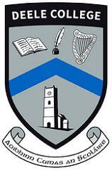
Deele College Booklist 2020 – 2021 Junior Cycle – 1st Year
Subject | Textbook Title | Publisher
English | Kingdom 1 (1st Years)  Selection of novels | Educate.ie
Irish | Tá Gaeilge Agam 1 (1st Years) | CJ Fallon
Maths | Active Maths 1 (1st Years) | Folens
Geography | Cyclone plus Skills Book | Gill and Mc Millan
History | Artefact | Educate.ie
Science | The Nature of Science | Mentor
Business Studies | Get Started | Folens
Spanish | Aprendemos 1 | Folens
Woodwork | Woodwork Materials Technology Wood Theory | Peter Cusack and Richard Foudy
Engineering | Junior Cycle Engineering | Brighter Minds
Technical Graphics | Technical Graphics by DCG Solutions | DCG Solutions /Cora King
Music | TBA
Home Economics | Skills For Life | Folens Edco

